Sped up Robust Features

Laplacian of Gaussian is approximated with box filter, which has calculation advantages

Orientation is approximated with 60 degree windows

Options for 64 or 128 dimensional features

Shortcuts are taken using signs of pairs laplacian determinants

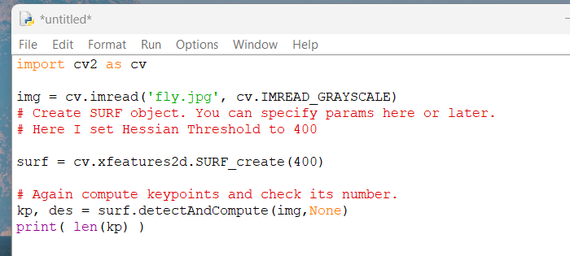

Code to find keypoints with a hessian threshold of 400

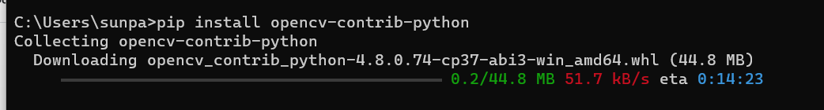

Had to (re?) install opencv contributions for python because i didn’t have the xfeatures2d module already installed?

SURF is actually not included in the python install i have because It is patented, i will try to find out how to install older python for non free modules later, ill skip for now